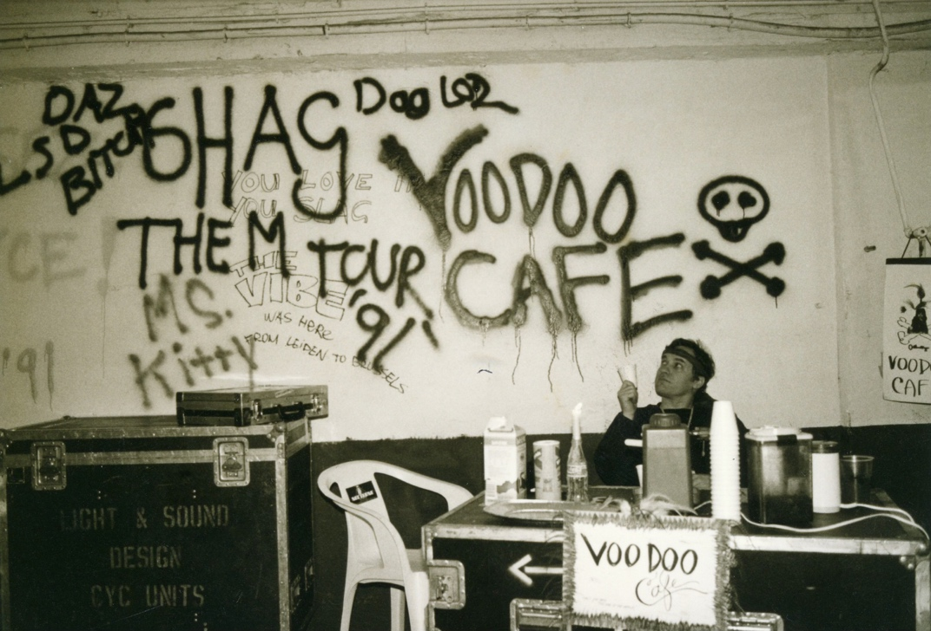

TALES FROM THE VOO DOO CAFÉ

Front Row Eyes
VooDoo Hilton
Sebel Town House
Drawing a Crowd
Snake Alley
Roppongi Nigel
Antonov Stories
Brawling on the High Seas
The Wheel of Blame
Ay, Carumba, it's the Repo Man!
The Pig Bowl
The Goldfish Caper
Bobcat
The World’s Best Putt Putt
Roadie's Wabbit Stew

Front Row Eyes

Most people have been to a big rock show, but have no idea what it really takes to bring it to their hometown.
There is a society of people that travel the world that you know nothing about. They bring entertainment to the four corners of the earth and all you see of them is the occasional black-clad streak racing to fix something during the performance. They work unbelievable hours, fly great distances on short notice, attack adversity with relish and always make the show happen, somehow.

There used to be an American fantasy of running away with the circus, to gain fortune and fame, to see the world, to be exotic and see the exotic. Wanderlust is not an uncommon disease, but for those born without a silver trust fund in their mouth, the realities of paying the freight for moving your ass from place to place come into play not long after you hit the road. Truly, to have someone buy you a ticket to the world, requiring an honest day's labor in return for a bit of free time in most of the major metropolitan areas of the planet, to explore and enjoy.
I've spent most of my career as one of these gypsies, making the road my home and bringing entertainment to people all over the world. I make my living as a video artist supporting popular touring musical acts, supplying them with big screen video support for their performances in large arenas and stadiums. As the business was growing, only the top ten percent of touring acts could afford this service, so one would only end up working for the acts that are currently the most successful. My photographic talents are that I can hold a large video camera very steady, and can interpret the music into my camera moves so that the pictures on the screens complement the performance on stage. Without our services the fans up in the cheap seats would only see a tiny spot-lit figure of the star on stage, but we can show them the emotion of the artist enlarged beyond life size. My position for many years was in the pit between the stage and barricade, making the close-ups of the star mostly my responsibility. To boil all this down to a one-liner, I’m the front row eyes for the back row seats.
Touring is one of those businesses where a normal sixteen hour work day consists of flurries of frenzied activity separated by periods of waiting and boredom. In order to keep myself sane during these slow periods, I have a number of ways to amuse myself, aside from harassing my co-workers. The Voo Doo Cafe is a product of this, in combination with my love of good espresso and my desire to share with my friends and fellow travelers. A large flight case contains an espresso machine and all the accessories, a cafe umbrella and chairs are placed somewhere behind stage, and decorations are added daily to enhance the ambiance.
The VooDoo qualifies as a true cafe in several ways, being an oasis from the business of stage and dressing room activity, a symbol of consistency in an ever changing environment, and a place to exchange information and gossip in an informal atmosphere where all are equal from the band members to the truck drivers. More about the cafe and it's origins later.
Who is luckier than us you may ask? A dream job getting to see the world and rub elbows with the rich and famous. It's not as glamorous as one might imagine.
Many days you have to work outdoors in rain, wind, and sometimes snow. Trucks bouncing over bumpy roads can be rough on gear, so often your stuff doesn't work and you have to stay late fixing it. You could compare it to working in an office, if your office moved 400 miles every day.
Most people can't fathom how we can start early in the morning, unload sixteen semi-trucks of staging and gear, put on an amazing performance by 8pm, and have it all back in the trucks by 2am and be rolling away to our next destination. As a concertgoer you don't have to worry about all that, the magic is our business.
How could anyone do all that week in and week out? How do we do it? Why do we do it? Traveling 8-12 months a year is trying on anyone, even the well-adjusted, and most normal people can't even imagine the lifestyle. You live in hotels, and spend your time in stadiums, arenas and tour busses, only seeing the local scenery when time or motivation allows. It take a special kind of person to do it, because you work 12-16 hours a day, and then get on a custom tour bus with your co-workers and sleep while it drives you to work for the next show tomorrow morning, hundreds of miles away. The successful people in this business have a drive to explore new frontiers, and do shows in places where no artist has gone before. Why do we do what we do? Well, there's not much call for pirates these days, the cold war is over and the secret agent business has gone to shit, and the pay is still lousy with the circus.

This is the story that gave the VooDoo Cafe it’s name. Perkins still ties flies in his room, but he always hides them before the maids come in to avoid a possible arrest.

VOODOO HILTON

Our stage manager, Perkins is a real outdoorsman at heart. Not being a big partier on days off, he’s got a couple hobbies that he carries with him to take up those excess hours in the hotel room between shows.
The new Langham Hilton had been open less than a week just off Oxford Circus in London and was trying very hard to earn a 5 five star rating. When we checked in we noticed that the only visable English employees were the two doormen out front, everyone behind the front desk was fresh out of German hotel school and all the maids were recent imports from the somewhere in the Caribbean.
Perk was sitting in his room in tying fishing flies with his kit spread out on the desk when the maid knocks on the door to service his room. Without moving from his chair he tells her to come on in. Once she opened the door he told her to just leave him some clean towels, no full service necessary. This West Indian maid walks in with an armload of towels and sees him sewing at the desk with bits of fur and feathers, then notices a plate full of clean chicken bones left over from the wings he got from room service the night before.
Perk is one of those guys who is very complete when he eats wings and the bones are fairly polished when he is done.
The maid’s eyes go wide as she puts two and two together. She squeaks and drops the towels, then leaves the room in a rush without another word.
Outside in the hallway she bumps into Julius, another one of our crew members who is the chatty type and asks her what’s wrong. She exclaims with eyes as wide as saucers, “That man is practicing Ju-Ju in there!" she said in a shaky voice. Chicken bones, fur and feathers meant only one thing to her- VOODOO!

She told Julius she was very upset and in fear for her life as she had been taught that if you see a voodoo priest preparing a spell, bad things will likely happen to you. Julius laughed and explained to her that Perk was only tying fishing flies. An explanation of fishing lures calmed her down a bit as they waited for the elevator, but I don't think she will be going back into that room for the rest of our stay. When they got to the lobby she made a beeline for the front desk to complain anyway.

The desk clerk’s eyes got wide as the maid told him of the guest in 326 who was casting evil spells in his room.
Julius had tagged along and tried to explain the situation to the young German desk clerk, who obviously had no knowledge of fishing lures.
“Don’t worry,” he told the clerk, ”he’s only tying flies.”

“Well sir, what does he do to the flies after he ties them up??” the desk clerk asked in horror, "I’m calling the police!".
Within an hour an inspector from Scotland Yard was knocking on Perk's door to investigate the practicing of black magic in a public hotel. Serious business. Luckily, the inspector turned out to be a Scotsman and a fisherman himself.
All discussion quickly turned to the relative merits of various lures and the possibility of working out a fishing trip to Scotland together without any pesky maids involved. They couldn't work out a schedule, but Perk gifted him a beautiful freshly tied “blue zulu" for his trouble.

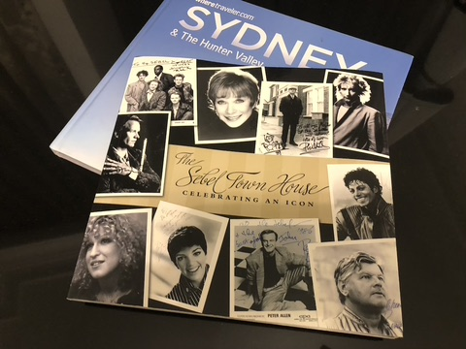

The Sebel was a famous rock ‘n roll hotel for many years in Sydney, sadly it got turned into condos a few years back but the legend lives on….

Sebel Town House

As I opened my hotel door and dropped my bags, I heard a screechy cheerleaderish noise coming through the closed window from the street. The Sebel Townhouse was for many years a roadie's favorite address in Sydney. Situated on a quiet, tree-lined side street a couple blocks away from King's Cross. The Cross is a lively neighborhood that never sleeps, which is handy with our erratic schedule, like needing a beer at 3:30am.
Which we very likely would, being fresh off the 14 hour flight from the USA and feeling the beginnings of jet lag setting in.

As I opened the window and stepped out onto the tiny balcony the crowd of twenty-five or so 14-year-old girls began to scream their heads off. Apparently the band was also staying at this hotel, and the hard-core fans had found out. They stood in a cluster down on the sidewalk and screamed every time they saw a curtain in one of the rooms slide open, thinking they were going to get a glimpse of the band.
Luckily I was only on the 6th floor so they could see that I didn't resemble a famous musician, and the girls soon went back to singing one of the band's hits at the top of their lungs.
After a few minutes the hotel doorman came out dressed in his fancy hat and long kelly green frock coat, hooked up a garden hose and waved a few sprays of water in their direction to chase them off, sending most of the girls scampering across the street out of range.
The doorman opened up on a couple of stragglers and soaked their carefully moussed hair, reducing it by about six inches in height. The girls squealed and dashed across the street to safety, where they turned around and began a new song, making daunting gestures at their adversary.

The doorman was a bit short of water pressure and had to move halfway across the street to be able to reach the girls with any effect. The girls backed down their sidewalk as a group, still singing, just out of range of the water. When the doorman finally ran out of hose he was well across the street and several doors down from the hotel with the girls still retreating barely out of range.
He was still waving the nozzle at them when a fire engine came roaring around the corner, lights blazing and siren whining up as the truck sped up the street towards the hotel. The doorman turned and stared, took a step back towards the hotel then stopped, seeing that was certain death.
He dropped the hose and stepped back as the truck sped past him. Somehow the hose popped up between the twin rear tires of the fire truck, catching just long enough to snap the metal spigot off the front of the building. After the truck had passed the doorman bent to pick up the hose, then noticed a fan of water spraying off the side of a parked car in front of the hotel. He dropped the hose again and ran across the street to see a solid jet of water shooting from a jagged pipe low on the hotel wall. The stream angled up across the sidewalk to impact the side window of the parked car, blocking the sidewalk and sending up a sizable fan of spray. The doorman stood and scratched his head with his gaudy coat hunched up around his shoulders from too much exercise.

The car window had been cracked by the flying metal spigot as it parted company with the building, and as he watched the window collapsed and the fountain stopped as the stream shot inside the car. The spectacular spray was now soaking the dashboard and seats as the water bounced off the opposite window and began to fill the car. He kneeled and tried deflecting the water with his hands, then realized that he was sopping to the elbows and no closer to solving the problem. He stood and shook his head disgustedly and walked right thru the stream of water, careless of soaking his beautiful coat and shuffled up the stairs to the lobby, presumably to quit his job before the shit hit the fan.
The car continued to fill with water as the now forgotten girls came across the street to observe the scene, then ran down the sidewalk and away, their laughter echoing off the buildings as they disappeared down the street.

Drawing a Crowd

One of the liabilities of fame is that you always draw a crowd, weather you want to or not. Autograph seekers, papparazzi, obsessed fans, and rubberneckers will gather around you and, if unchecked, can build to critical mass and become uncontrollable and very dangerous. And running is the worst thing you can do. I've had teens hanging onto the baggage rack of a van while it speeds away, and seen them fall off at 30mph.
As a musical artist you try to write lyrics that touch people, which if published widely enough can lead to success. Sometimes people take it all too seriously and identify so deeply with the meaning that they attach to your work that they act completely irrationally. Remember that "fan" is short for fanatic. Groups of fans might start screaming and clawing just to touch you- not you as a normal person, but the idea they attach to you- a fantasy created by their interpretation of your art. Touching the soul of the common man is what makes art or music popular, but it can be a dangerous thing for the artist once they acquire a bit of fame.
In certain large cities there is an understanding of fame, such as New York or San Francisco, where those of notoriety can expect a bit of respect from the locals, and receive knowing glances in restaurants rather than being hounded for autographs by the next table. But most places on a long tour are more like Des Moines or Manchester, and this visit may be the local fan's only chance to touch or speak to their idol.
One thing most teen idols have in common when at their peak of popularity, is that when they visit a city for a concert, their hotel will be surrounded with a cadre of hard core fans, singing, screaming, and hoping for an autograph or the chance to touch one of the famous.
Everyone wants acceptance, to be included and praised, and most people who have never been would like to be famous. I've always thought the smart ones were the rock n rollers who never put their picture on their album covers, so they can still visit the grocery store in peace, without drawing a crowd.

While touring with Bon Jovi in Chile, we experienced a day that was right out of the movie "A Hard Day's Night". Blessed with an extra day off, five of us took a van and an interpreter to the beach about an hour from Santiago for a relaxing day on the sand. With our long hair and t-shirts there was no way that we would be mistaken for locals, but most people we dealt with were friendly, and quite helpful even with our inability to speak Spanish. We stopped at an uncrowded beach and stretched out to catch a few rays.
After about 20 min. I opened my eyes when I heard the click of a camera and realized that there were about 10 people standing around us in the sand, staring and taking pictures. A couple of people asked for autographs, and refused to believe that we weren't the band, just some of the crew trying to enjoy a day off. The crowd began to grow and surround us, and no one was buying the fact that we WEREN'T the band. It was obvious that things could get out of hand rather soon, so we picked up our towels and went back to our van with the crowd of onlookers trailing closely behind. We piled into our vehicle and waved, then drove a couple miles down the beach where we could relax without being bothered.
We reinstalled ourselves on the sand, and were watching penguins sunning themselves on the rocks (wow, we were further south than we thought!) when we noticed the crowd, now swollen to a couple hundred people walking up the beach to look at us. It was obvious that we were going to get any peace on this beach, so back in the van we went to escape the throng. Before we could drive away, they had surrounded the van and were pounding on the windows and screaming like we were the Beatles or something as we tried to drive away slowly enough to avoid injuring anyone.
The next day there was a picture in the Santiago Times newspaper of the five of us stretched out on the beach, identifying us as the members of "los rockers Bon Jovi, relaxing on the beautiful beaches of Chile". No one bothered to ask when the bass player had gained 150 pounds and turned blonde.

Snake Alley
Taipei, Taiwan

One of our favorite attractions while visiting Taipei was the Night Market. Under swinging light bulbs a wild variety of foods and trinkets are sold by vendors in stalls and galleries covering several city blocks. One end of the market has been dubbed "Snake Alley" because of a particular type of shop. Many Chinese still eat things we would think quite strange in the west for their legendary medicinal purposes. Eating snake is said to be beneficial for virility and fertility according to ancient herbalist customs. Even if you aren't in a tasting mood, it's worth the visit.

Mo's Snake Shop
I guess it was called Mo's, but I couldn't decipher the Chinese characters on the sign anyway. It might as well have been called Snakes-r-us, because everything in the small open storefront had something to do with snakes or Chinese herbs. In the open front of the shop where the front window should have been, stood a man with four dead snakes hanging from a coat hanger. He was methodically skinning them one at a time, with the skill of long practice. The shelves on the walls of the shop were covered with a wide variety of jars and bottles in all shapes and sizes, each containing a snake marinating in some kind of liquid. There was snake wine, snake oil, snake elixir, snake tonic and plenty I couldn't identify. On one side of the room there were several small tables with a few customers drinking beer from tall bottles and eating.
The place is also a restaurant and serves snake more ways than Bubba Gump served shrimp. I saw people eating snake soup, fried snake on rice, and drinking fresh shots of snake blood. This last item is only consumed by the hardiest customers, or those in great need of a boost of their libido. A couple of our companions sampled a shot, and while nobody hurled on the spot, they weren't clamoring for seconds either. Reports were inconclusive as to the effect of drinking the blood, and was impossible to tell if it made them any hornier than they were when they walked in the door.
I guess the owner figured that he needed a centerpiece for the place, so his fine shop would not be confused with just any run of the mill snake shop on the street. On a small platform in the center of what passed for the dining room was a live, half grown orangutan, collared and leashed with a chain to the ceiling. I have to admit that the owner's idea worked, you never forget a restaurant with an uncaged live monkey hanging around in the dining room. The Orang had possession of a paper cup, and made a career of bumming beer from the patrons at the tables. If no one was forthcoming with a bottle soon enough for his satisfaction he would set up a loud screeching while he waggled the cup beseechingly, which usually scared some beer out of those customers sitting closest to him. While I usually agree with those who think this kind of animal treatment is cruel, it's tough to beat watching a drunken monkey swinging on chain for pure hilarity. The local Taiwanese seemed to think it was the funniest thing they'd ever seen.
One of our party was a redheaded girl whose hair color was pretty close to the orangutan's. Even though she wasn't amused by the comparison, the animal still fascinated her. She approached the ape making cooing noises like "ohhh what a cute monkey." and trying to make friends. He reached out and touched her hair gently, and she touched his hand.
It was all a really sweet scene deserving of violins in the background. Then he reached out and tried to peek down her blouse, to the great amusement of everyone.
She tried too late to get out of arm's reach, but the ape had decided he really liked her and got a grip on her to pull her closer. She freaked out with a squeak, and tried to pull the ape's hand off her.
All too late, she made the sudden unpleasant discovery of how strong half-grown orangutans really are. She couldn't even budge his hand.
Realizing that he was about four times stronger than her made him seem not quite so cute in a real hurry. Now she really started wailing and tried to drop to the floor to get out of the ape's grasp, but he got a good hold on her blouse and ripped it. One of our guys had come to the rescue and started punching the orang trying to make it let go, and the shop's manager showed up in short order carrying a thick broom handle and started seriously whacking on the ape also, until the orang finally gave up on his new love and let go with a dejected sigh. The beating had never fazed him in the least, but he did look a bit depressed at having to give up his newfound friend.
After receiving many apologies from the owner we departed because the redhead was pretty shaken by the whole affair. As far as I know she hasn't been to the zoo since, and at last report the ape was still acting like a jilted boyfriend and drinking heavily.

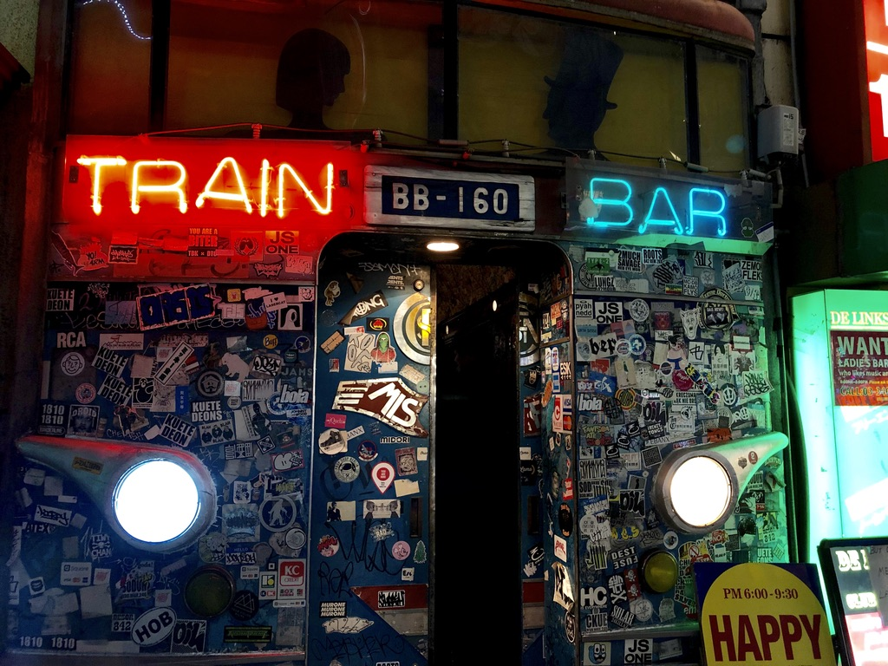

Roppongi Nigel

One night on the street in Tokyo I met an Englishman selling silver on Roppongi-Dori Avenue, with a table full of rings and bracelets, a sidewalk entrepreneur. A rather common occupation in a very uncommon place. The Tokyo ghetto for foreigners is known as the Roppongi District. The area caters to the foreign tourist more than any place in Japan, but it would be more accurate to say that here is where they let the "gaijin" (foreigners) run amok with very little interference. The area is a three-dimensional maze of clubs, bars and restaurants large and small, many hidden away on the upper floors of buildings with very few signs. A typical Roppongi experience is to get into a tiny elevator in what appears to be a small office building, riding up and having the elevator open on the 8th floor directly into a disco at full volume, strobe lights flashing and rocking hard but invisible from the street below unless one knows where to look. The neighborhood is notorious for late night debauchery, and for someone who is willing to spread some Yen around in the right places it's possible to find drugs, girls, and any of the usual vices one would find in any major city in the world. The local cops seem to turn a blind eye so long as the gaijin are selling things to their own kind and not corrupting the local Japanese, or become so blatant with their business that they become a public nuisance. While most Japanese that you meet are really nice people, Japan can still be a pretty racist country, a former feudal state with a thin layer of democracy spread over it like the seaweed on a tuna roll. The racism comes from the isolated island mentality cultivated by their leaders over the last few centuries, stating that you are either pure Japanese or you aren't. Even if you are half Japanese you are still an outcast by their standards. And if you are not Japanese, you are Gaijin. Many restaurants and bars will refuse to even let you walk in the door, and won't serve Gaijin unless they are accompanied by a Japanese partner, or can speak the language well enough to embarrass the doorman. Living with totally strange customs and language is a strain on most ex-pats, especially in a society as regimented as Nippon. After a full day of dealing with the pressures and strict customs of doing business in a Japanese office, they often need to blow off some serious steam. Foreigners and Japanese alike fill the sidewalks every night in search of heavy drinking and late night entertainment. Even in a society as regimented as Japan, there are still cracks in the economic woodwork where the hustlers strive and survive, outside of the system and protected and/or ruled by the bigger fish in the shadow world.
Nigel has been selling silver jewelry on the streets of Roppongi district for six years now. It's a seasonal job, from early June to the end of October when the weather is pleasant enough to work on the sidewalk for 12 hours a day. For nearly five months a year he works 4pm to 4am, seven days a week. He makes enough in a season that he really doesn't need to work for the rest of the year. He spends the rest of his time in Thailand with his Thai wife, or traveling as he wishes. An expatriate of London, he hasn't returned to Britain in six years and has no plans of doing so. He buys silver jewelry in Bangkok and outlying towns at bargain prices then brings it to Tokyo and sells it in one of the most expensive places in the world. I was fascinated to find him on the streets of modern Tokyo, plying the trade of merchant in much the same manner as people have since traders rode camels from China to Turkey bringing exotic goods from far away. When he first came to the Roppongi and set up his table on the sidewalk, he had to compete for a space daily with the other vendors, not always successfully. Whenever business was bad on the street, the owner of whichever restaurant he was camped in front of would call the cops and have him removed, claiming he was blocking their sidewalk and ruining their business. Funny, but this only happened when business was slow, never during the busy times. Despite the hassles, he was making more money than he ever had, and when the rain started in late October, he returned to Thailand to rest up and re-stock, vowing to return.

Early in his second season in the Roppongi, a Japanese guy introduced himself to Nigel after seeing him get the bum's rush by the cops, and offered to help him with his location problem. No one in Japan ever says the word "Yakusa" or "mafia" out loud; it is only whispered with great caution while looking over your shoulder. And while the name was never mentioned, it was obvious that the guy was the local Japanese mafia rep, who offered to guarantee him a good location on the sidewalk every day for a small weekly fee. From then on Nigel always set up in the same place, and the business owners left him alone to sell his silver without interference. Over time, his friend from the Yak would ask him about other vendors on the street, who should be favored with good spaces and who wasn't cooperative enough to deserve help from them. One afternoon Nigel arrived to set up his table, and his space was already occupied by an African guy selling knock-off purses from a blanket on the pavement. Nigel asked the guy to move so that he could set up his stand, and was told to "screw off, first come first served."
"That’s not really the way it works here mate," he told the purse salesman, which only resulted in more belligerent comments, and no movement. Finally the guy got up and started pushing Nigel around, trying as hard as he could to start a fight and chase Nigel off. One of the metal table legs Nigel used for his stand was leaning against his van, so he picked it up and whacked the guy in the head with it. The African picked himself up off the pavement and rushed Nigel again, and got an even harder whack in the head for his trouble. Nigel had to hit him twice more before he would stay down and quit fighting. The guy was still bleeding from the head when the cops finally showed up and hauled them both away. Later that afternoon, Nigel was in jail and very worried about being deported. A cop took him out of his cell and up to an office for what he assumed was yet another round of questioning. To his surprise, his Yak friend was waiting there in the office, having showed up without being called and proceeded to get Nigel released without paying any bail. As they left the jail, the Yak told him that he had good news and bad news for Nigel. The good and bad fell out like this, He wasn't going to be deported, but it would cost $10,000 to get the charges dropped. But the best news was that he no longer had to pay the Yakusa for "insurance" on his space on the sidewalk, in fact he was to be in charge of allocating sidewalk space to all the vendors in his zone on the street, and collecting a fee from them if he so desired. Of course he had to share whatever he collected with the Yak, but he had earned respect in their eyes by taking care of business by himself without calling the police or asking them for help.
Nigel is in his seventh season by now, and he hasn't had to beat anyone up since the one incident. The owner of the noodle shop that he sets his stand in front of has never become friendly, but he never gets hassled by the owner or the cops, and he does his part to keep his portion of the street free from bad vendors and rip-off artists. He's just living in the cracks of Tokyo, doing a small public service while selling silver to the passing crowds, working the pavement in a very strange place.



Antanov Stories

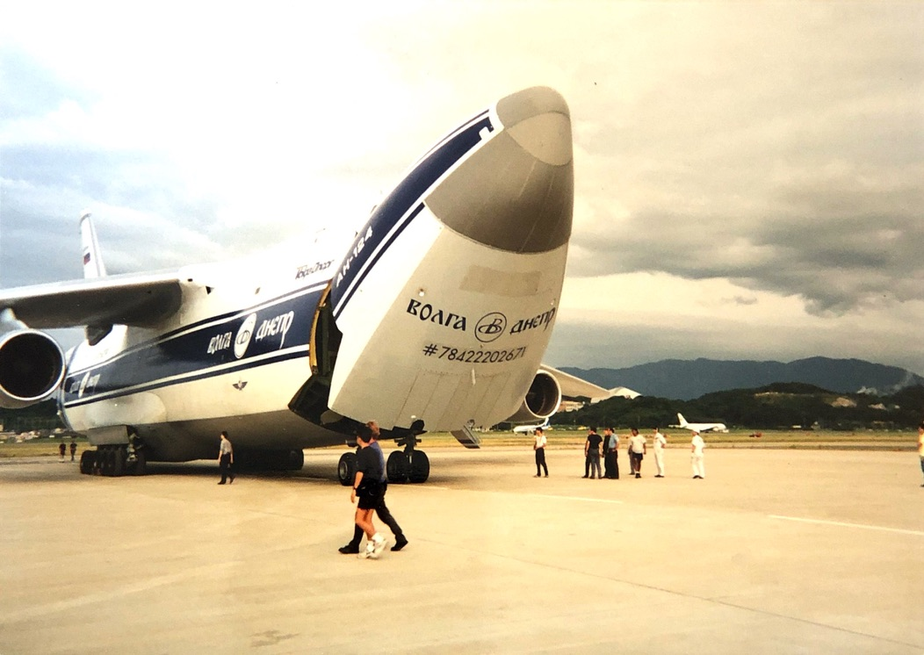

This is a little story about life on a cargo plane.

The Antanov A-124 is an extremely large Russian cargo plane. It is their version of the American C5-A. For those not familiar with military aircraft, when an Antonov is parked next to a 747, it looks like a rotweiler sitting next to a toy poodle.
They were originally built by the Soviet armed forces, designed to transport 8 tanks from Moscow to Kansas City and land in a cornfield. Planes of this size need to be flown regularly or they are impossible to maintain. After the fall of the USSR the planes needed a new use, and an English company named Heavy Lift was formed in partnership with the aviation complex in Ulyanovsk, with support from the EEC. The English book the jobs and deal with landing rights, and the Russians deal with the actual operation of the aircraft. The planes are still flown by mostly Russian crews, still divided into cargo and flight crews as they were in the days before Glasnost, with very little communication between the two. The flight crew maintains an upper class attitude and most won’t associate with the lowly cargo and mechanic guys, even though they maintain the aircraft. In the three months I flew on the planes I only had occasion to speak with one of the flight crew members. We were riding in the back, and American or not, we were just cargo lowlife to them.

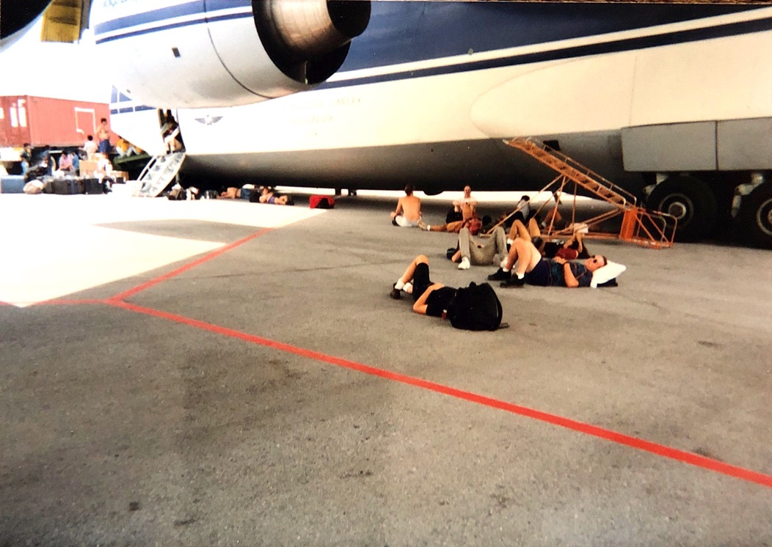

A large reason for the lack of communication is the cabin configuration.

The cargo area of the plane is 21 feet wide by 18 feet high by 120 feet long. The nose and tail open and large ramps unfold from each end, making it possible to drive right thru the plane. If you imagine that the bubble on the front of a 747 extends full length to the tail of the plane that will give you an idea of the crew compartments above the cargo. In true Russian tradition there is no door between the flight deck in the front half and the cargo crew/passenger zone in the rear. Access is by two folding ladders, one each at the nose and tail, making it impossible to get from the rear compartment to the flight deck while in the air, because the cargo area below is not pressurized.
At our suggestion the crew cabin had been outfitted with sixteen military bunks, four abreast, leaving only a one foot aisle down the middle. The bunks were plywood with a one-inch mattress and military-issue pillow. Mine smelled like twenty years of scared Russian soldier. The accommodations were considered luxurious by Russian military standards.
Two booth tables provided a dining area, and behind them a small galley and coolers, a hatch in the floor covering the ladder to the cargo bay, and a bombardier’s chair, complete with a bomb sight which gave a view of the cargo bay for mid-flight drops. The head was also a very Russian design, two toilets facing each other with no divider, cramped between bulkheads. This was the only place the Russian crew was allowed to smoke, and a trip to the bathroom usually meant dislodging two of the guys who would be sitting on the facing thrones.
In the entire length of the crew cabin there are only 4 small porthole windows, each about six inches across, making sightseeing difficult during takeoff and landings.

We had a Russian crew of five riding in the back with us. Out of the five, three of them were named Vladimir. Vlad-one was the jet engineer and the friendliest of the bunch, even though none of them spoke any English. A rather jolly Ukrainian, he also became known as Luigi, because of his resemblance to Super-Mario’s buddy in the video game. Vlad-two was called Spock because of his haircut. Spock ran the 10-ton overhead crane mounted on the ceiling of the cargo area. Vlad-three was the cargo boss, a balding sour-faced Russian with a lot of gold teeth and no sense of humor. We had to delicately explain that being number three meant he was the boss (rather than the fact that he was the only real asshole on the plane) but the language barrier made him confused and he gave up without understanding our line of bullshit.

Communication is a real challenge when you don’t even have a common alphabet and are reduced to pointing and a lot of sign language. Your natural urge is to slow way down and talk louder, but that usually doesn’t help. Handing a dictionary or phrase book back and forth slows it down so much that you can only maintain interest in the most basic of questions. We tried to get to know the guys during long flights, but the conversation usually dwindled to pointing at maps and nodding a lot pretty quickly.

Usually we would have some regular airline food delivered to the plane just before take off, but the Russian crew was not accustomed to such treatment and were prepared to take care of themselves. They had jury-rigged a hot plate to run on the plane’s electrical system, and would make themselves a large pot of stew during long flights. Shortly after take-off on each long flight, the most junior Russian would be seated on a box in the galley, peeling potatoes for the soup.

On takeoff there is a routine of sitting on the end of the runway and running the engines up to full power for four minutes before letting go of the brakes and starting the takeoff. An average takeoff with full payload takes about 25,000 pounds of fuel. As you sit at the end of the runway the engines shake the plane so much you think you must be rolling down the runway at high speed. Once they let go of the brakes and everything on the table starts to slide you realize that you were only sitting still. The actual run to take off only lasts about 30 seconds, and the wings flap as you roll down the runway. Rather, they tend to bounce as you gather speed, then finally stick in the up position and heave the belly of the plane off the ground.

Our longest flight was 22-hour leg with two fuel stops from Fukuoka, Japan to Moscow.
The first fuel stop was at a military airfield somewhere near Vladivostok. With only the tiny portholes for a view we couldn’t see much as we landed, and once we taxied to the end of the runway and parked there were no visible lights outside anywhere. After about an hour on the ground boredom set in, and I decided that this was the perfect opportunity for me to set foot on eastern Russian soil for the first time. The cabin was fairly warm and I was dressed in a t-shirt and shorts, but I wasn’t planning to be outside long, so I slipped down the ladder and started climbing forward over the cargo to the open door in the front of the plane. My eyes were adjusted to the light inside the cargo bay, so when I reached the door the airfield outside looked blacker than the inside of my pocket. As my eyes adjusted to the dark outside I could see a screen of trees at the edge of the runway, but there was nothing else in sight. A chilly breeze was blowing in the door, and once I stepped onto the ladder to the ground I realized that it was about 45° outside and I was barefoot. A Russian soldier with a flashlight came around the nose of the plane, having seen my shadow from the light flowing out of the doorway. As he stepped into the light I saw he was about 19 years old and dressed in winter military uniform including the furry hat. Armed with a flashlight, he was approaching the ladder and motioning me to get back on the plane. I continued down the ladder and he met me at the bottom just as I jumped to the ground. I stood there and looked around at the darkness while he babbled excited Russian at me and pointed back up the ladder to the door. I really wasn’t dressed for an excursion but his excitement somehow made me want to delay as long as I could. I finally grabbed his flashlight and pointed it straight down.
“What do you think,” I asked him, “Am I going to take over Russia in my bare feet?!”
My laugh confused him even more, and as I scampered back up the stairs to the warmth of the cargo bay he stood his ground, defending his post with a flashlight.

We took off again to continue the long flight over the western part of the former Soviet Union, we made our second fuel stop at a military airfield in Siberia. The term ‘military airfield’ doesn’t make much sense in the USSR because at the time there were no private airfields there. We weren’t allowed to get off the plane, and were only allowed a look around through the tiny portholes in the cabin. Tall pines surrounded the runway, and only a couple of ramshackle buildings were visible. The only other sight of interest was a scrapped Antanov plane which had obviously been pushed off the runway to the side, crumpled off it’s landing gear and rusting, windowless in the field. While we watched the small fuel truck make several trips to fill us up, Vlad-one had the cowling open on one of our outboard engines and was tinkering away at the top of a ladder. After a while he got off the ladder and drug it across the field to the wrecked plane. He opened the cowling on an engine and removed a small part, then moved back on the runway and plugged the part into our engine. When he boarded the plane I asked Vlad-one what he had fixed, and he gave one of the guys the bad spare part, but no amount of translation or sign language could determine the function of the part. We revved up and took off for Moscow, and everything worked fine, I guess.
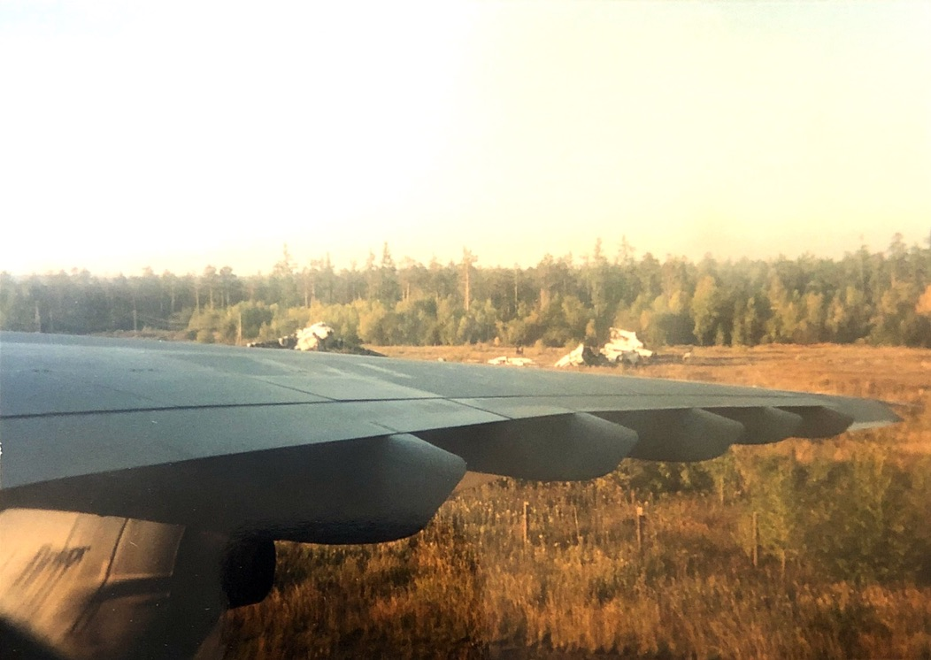

We landed in Moscow without incident and unloaded to do a couple of shows in the stadium there. As usual when the second show was over and we were beginning the load out, Benny our production manager called Morris our airport liason who coordinated all our cargo moves to check in to see if they were ready for us to start sending gear to load the planes. “Ben, we’ve got a bit of a problem here that is going to slow us down. Both planes are full.”
“That can’t be!” replied Benny, “We have an exclusive lease on both of those planes for the duration of the tour.”
“Well, I’ve been asking questions but no one is coming up with any answers.” said Morris. Turns out while we were at the stadium in Moscow for 4 days both planes had done a quick round trip to Amsterdam and returned packed to the roof with Snickers bars. No one at the London HeavyLift office had any knowledge of it and no one at the Moscow office would admit to shit. Morris was faced with 120ft by 18ft by 21 ft times 2 of candy bars packed to the rafters, with only 4 guys and a forklift to get them unloaded.
Once we showed up at the airport with the first 8 trucks and our loading team we managed to cover the tarmac with boxes of candy bars pretty quickly, got our stuff loaded and went on our way after keeping a couple of boxes so we wouldn’t run out of candy for the rest of the tour.

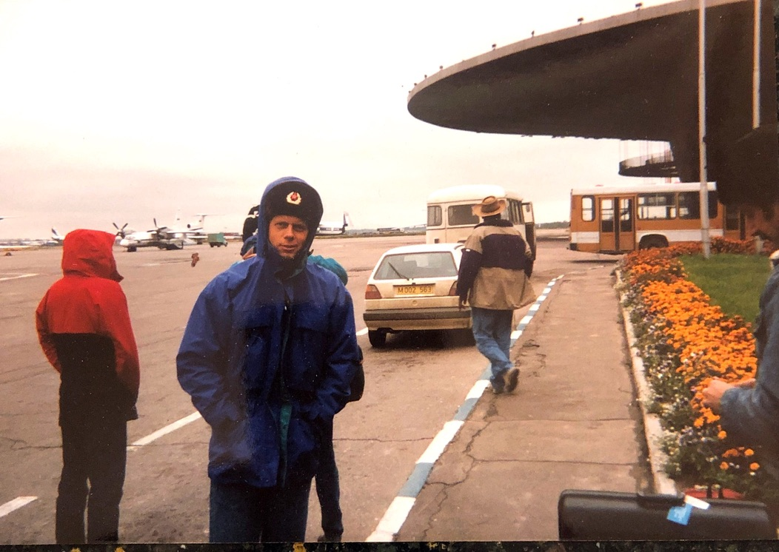
Most of the places where we landed had never seen an Antonov before, so we were often the center of attention once on the ground. Security guards and airline workers from Japan to Mexico would come to watch us unload, and pose for pictures in front of the giant planes.

Our usual routine went something like this. After landing we would immediately start unloading the planes, and if everything was working right there would be twenty locally hired trucks waiting to take the gear to the stadium. There would also be a local crew of guys to help with the unload, sometimes experienced but usually lame. We landed in Istanbul expecting to deal with one of the lamest crews yet, but to our surprise there on the side of the tarmac were 40 Turks wearing Rock-it Cargo shirts, which turned out to be the best crew we had seen. No slacking, no shirking, these guys tore into the cargo like a dog digging desperately for his favorite bone. It turned out that they were a warehouse crew who worked together on a regular basis, with a crew chief who would keep them moving and knock heads when necessary. These guys were motivated! After taking something down the ramp they would actually run back into the plane for the next piece. The trucks began to arrive, and our false sense of security was shattered. Almost half the trucks had such rotten floorboards that there were bowling ball sized holes in the floor, and those which had been patched with scraps of lumber were nearly impossible to roll anything into.
As we worked the sun began to set, highlighting the minarets of a mosque at the edge of the airport. A small armored personnel carrier patrolled the edge of the runway, more rubbernecking by the local security. One of our guys made friends with the driver, who let him climb in and pose for a picture, before his commanding officer showed up and gave him holy hell for letting a civilian fool around with the APC. We gave them both t-shirts to take the heat off the guy and tried to explain that the vehicle was no big military secret, because the Miami police own four of them.

PERU

We were supposed to do a show in Lima, Peru, but the government was a major sponsor of the promotion and there was an apprehension that we would become targets of the Shining Path guerrillas if we did a show in Lima. A car bomb had exploded outside a businessman's hotel in Lima the week before, and this turned the tide. The final decision not to do the show came down while we were in Santiago, and the non-Antonov crew flew out direct to Mexico City. With all the heavy equipment we were carrying on the cargo planes, we could only take on enough fuel to fly for five or six hours, which meant that we had to make a fuel stop at the only logical place between Santiago and Mexico, which happened to be Lima.

When we landed our planes were directed to pull up to the terminal nose first. Keep in mind that jets don’t have a reverse gear, so we were stuck until the authorities decided to give us a push back to take-off position. Supposedly no one in Peru knew we were coming or what we were carrying, but it’s hard to maintain a low profile in a pair of 800,000 pound planes. The planes are so heavy that they carry their own push rods to tow the plane into take off position. Not long after we landed a couple of commercial airliners were parked directly behind us, effectively blocking us in.
After several hours on the plane, we all wanted to get off the plane and stretch our legs on the tarmac, and came down the rear ladder and clambered over the 120 feet of cargo to the front side door, which was the only one opened during fuel stops. Just as we reached the door our Spanish translator met us at the door and told us to forget it. Things were a bit tense outside and if a gang of Americans were spotted milling around outside the plane the locals might get some really silly ideas.
The Peruvians wanted this show very badly; in one communication it was called a matter of national pride. If they figured out that everything needed to do the show except the star was sitting at their airport, they were completely capable of delaying our departure indefinitely. One of the Russians came rushing back into the plane to change his shirt, after being severely scolded by Vlad-three for wearing an MJ security shirt outside to assist with the fueling. He changed into the usual drab Russian shirt with this silly ‘oops’ look on his face and went back outside. Everybody climbed back over the cargo to the back of the plane and went up to the cabin, but I stayed down in the cargo deck.
By sitting on the side of the rear cargo ramp I could see down the length of the plane through a narrow gap between the piled gear and the wall of the plane to the open door in front. If we were going to be boarded by the Peruvian Military, I wanted to be able to see them come through the door, which would give me a couple of minutes to get upstairs and raise the ladder behind me while they climbed over the cargo. After about 45 minutes of watching it became apparent that no one was coming on board, and there wasn’t anything we could do about it anyway, so I went back upstairs and joined the running poker game in the cabin. Once in a while one of the Russians would come back upstairs, and when asked how it was going outside they would just shrug and tap their watch.
As we were sitting there, a low boom was heard from outside and the whole plane rocked, as if someone had run into the side of the plane with a service truck or something. A look out of the starboard porthole showed a column of smoke rising from the terminal building, but not much other movement outside.
Apparently a car bomb had just gone off in front of the terminal, killing two people and taking out all of the windows on the front of the building. Our translator was the only one outside the plane at the time, and was in a phone booth when the bomb went off about 250 feet behind of him, showering his back with glass. He wasn’t hurt, but when he came back on the plane I wouldn’t describe him as a happy camper. Naturally this stopped all work at the airport for quite a while.
After six hours the poker game ran out of steam, and we still weren’t fueled up and there were still two planes behind us blocking us in.
Having no other choice of action, I gave up and went to bed.
A couple hours later a movement of the plane woke me up, and we were being pushed back for take off after about 10 hours on the ground.
We landed in Mexico City about dawn, and our advance crew was very happy to see us safe and in one piece as they had already heard about the bomb.
We will never know if the bomb was directed at us, or if our presence at the airport was just a coincidence when it went off.
I had the feeling of having stuck my head in a lion’s mouth and escaping without a scratch, only because the lion was yawning, not hungry.

Brawling on the High Seas

In what I imagine was a nice warm office somewhere in New York, someone decided that it would be a good idea for us to tour Scandinavia in mid-December. An easy decision for someone who would only have to count the money from afar as we dragged the rock show across the tundra.
Normally you hit the four major cities, Oslo, Copenhagen, Stockholm and Helsinki.

After that, plans are to park us in a London hotel for Christmas.
Needless to say, the crew is not pleased. No time off for Christmas, and tensions among the crew are running a bit high.

The Stockholm-Helsinki run is usually accomplished with a 12-hour ferry ride on one of the largest ferries afloat. They have about 14 decks including several car park decks and lots of entertainment for the travelers. Several restaurants, a casino and a disco help fill the time, and the rarity of tax-free booze in Scandinavia really brings out the best in people. Drinking commences as soon as the ship leaves the dock, and most travelers don’t have the stamina for a full 12 hours of drinking so everyone is assigned to a 4-bunk stateroom so one has a refuge from the wandering drunks.

About 5 hours into the voyage the disco opened and having become bored with the regular bars on board, most of the crew headed there. Challenge drinking continued, as well as mixing and dancing with the locals. At one point Fats, our one black crew member was on the dance floor with a nice looking Swedish blond woman while we looked on from the sidelines.
Pat, our proud Tennessee redneck lighting director gets a tap on the shoulder from a Swedish guy next to him. Of course the music is blasting in the disco so any conversation needs to be conducted by yelling.
"Tell your friend to stop dancing with my wife!" yells the Swede
"What? Says Pat
"I said "Tell your friend to stop dancing with my wife!" yells the Swede
"He ain't my friend" says the redneck and turns back to his drink.
The Swede starts showing his alcohol consumption and continues to annoyingly poke Pat in the shoulder.
"Tell your n****r to quit dancing with my wife!" he yells
Nearing his boiling point, Pat declares, "Hey, you can't call our n****r a n****r!!"
The Swede isn't backing down and says, " I am with the Swedish police!" to which Pat replies "Well fuck you, I'm from Tennessee!” and pops the guy in the jaw.

A note to travelers and local bar patrons. If you are in a bar and it seems there is a road crew drinking there, it is inadvisable to start an altercation with a member of said crew, unless you happen to be drinking with 30 of your own friends. While we might not be best friends with everyone we happen to be traveling with on tour, and are generally friendly to all the locals we meet, we will always leap to the defense of any of our boys confronted by a local asshole. I’ve seen this happen many times, where a town bully takes exception to a road guy chatting up his girlfriend and decides to pick a fight. Suddenly he finds himself surrounded by 10 or 20 roadies who wouldn’t really mind a good brawl to blow off some steam.

Due to the volume in the disco, no one overheard the conversation, but when fists began to fly a full-scale brawl broke out like a match on gas.
Good thing that it was a boat and the furniture was bolted down, or it would have looked like one of those old time western saloon fights with tables & chairs flying. Eventually everyone got separated and told to go to their cabins and sleep it off if they know what was good for them.

On arrival in Helsinki, we all kind of tip-toed off the boat hoping there were no local police waiting for us on the dock, but all was calm and we proceeded to the hotel.

After doing the show, we realized that we had to get back on the same ferry to return to Stockholm. We boarded the boat and headed to the first bar in the traditional manner. There seemed to be a lot of big guys already there, and after a couple of drinks we discovered that for some reason the Finnish National Boxing Team was on board with us. They were a nice bunch of guys, and we all declared solidarity with the Finns. Later in the disco, when Fats started dancing with the local blondes again, we stuck with the Finns and let Fats solve his own problems.

I believe this is the only brawl I was ever involved in that had a commemorative t-shirt made for it.

The Wheel of Blame

Sometime during the MJ European tour, traveling with a crew of 150 people, I invented a great stress reliever.
I mounted a pointer on a board so it would spin, and drew a wheel around the pointer. I cut all the names out of the itinerary and pasted them around the wheel, managers, vendors, everyone from the truck drivers to the big wigs.

Have you ever heard anyone sell snake oil?
Imagine a barker in a tall top hat standing on a platform in front of a crowd, spouting the following speech with a slight W.C. Fields' accent.

"Ladies and gentlemen, here before your very eyes is a modern device, simple yet unique. This amazing machine harnesses the powers of the universe, for a modern purpose that anyone can understand and use in their daily lives.
Using Newton's Law of gravity, ancient Taoist philosophy, and a pinch of bear grease, it demonstrates the reality of "Random Blame Theory". With each rotation of the specially balanced pointing device, it solves a universal, common human problem by answering many of the daily questions of the working man or woman, questions like - "Who did this to me?", or "Who broke this while I wasn't looking?", or "What moron put all this crap in front of my stuff?"
"Anytime anything goes wrong, or breaks, or goes snafu in any way, it is now possible to assign blame on anyone at any time for just about anything. Just reach out and spin the specially designed pointing apparatus, and immediately find out who's fault this screwup really is. Any student of advanced mathematics or quantum physics will agree that in practice, the random assignment of blame is just about as effective as the normal process in any group of people."
"Any one of your friends, neighbors and associates can be added to the wheel, but once you're on, you're on for good. If you leave the tour, you stay on. If you ask to have your name removed, you stay on. If you meet with misfortune and die, your name will be removed for one year out of respect, then it will be re-added in your memory. Because of the effects of the Random Blame Theory, even if you are only present in spirit, it could still very well be your fault."

The true power of the Wheel was demonstrated once in London. An MTV host person was doing backstage interviews and wanted to do a piece on the traveling café backstage. I went thru my usual shpeil about the VooDoo, and showed her the Wheel of Blame. After the explanation, she couldn't wait to give it a try herself. She gave the pointer a mighty spin and it landed on Rat Boy, the laser tech. "Rat Boy, you're outta here!" she cried while grinning into the camera, obviously caught up in the spirit of the thing.
Funny thing, two days later the tour accountants made an unauthorized decision and sent Rat Boy and his lasers home without notice. He got his job back once everyone came to their senses, but I'm still glad I only let her spin the Wheel once, who knows what problems it might have caused.

In Philly on a different tour, there was a real fortune wheel stored backstage, normally used to give away US Air vouchers for hotels or airfares during halftime at the NBA games. We took pieces of paper and taped them to the wheel, listing everyone on the tour from Irving Azoff to the truck drivers. After a few test spins, it became apparent that the same guy came up too often, so we straightened a few spokes of the wheel to make it random again.
We were set up in a hallway between the dressing rooms and the stage, the band noticed the wheel on their way to stage and had to stop and give it several spins as they quite enjoyed meting out blame for various wrongs both real and imagined.
After a while the local guy who was in charge of the wheel came by and saw our modifications. He freaked out, ripped all the carefully taped names off the thing, and dragged it off angrily to parts unknown. In place of the wheel we put up a collection jar to "buy someone a sense of humor", and during the loadout presented the angry guy with $3.86 in small change.
I had forgotten that we were in Philly, not the easiest place to find an honest game of chance. Their wheel had spaces on it to give away plane tickets and free hotel rooms, with only a couple of loser spaces. Then I realized that we had fixed his "fixed" wheel, and he suddenly stood a chance of actually giving away several thousand dollars worth of airfares at the next 76ers game........
No wonder he freaked out, we fixed his "fixed" wheel.

Ay, Carumba, it's the Repo Man!

The Scene:
The Tejano Music awards are a major event every year in San Antonio, even if the rest of the world doesn't hear or care about it. Tejano music only thrives along the US/Mexican border, a mix of local traditional music with rock, country and pop. I think the only thing all the bands have in common is an accordian player, and lyrics in spanish or spanglish. Each year 35,000 people turn out at the Alamo Dome to celebrate their local stars.

One popular band in this affair is El Tropa Efe, (yes, that's F Troop in spanish!) a band of 8 plumbers who perform and record as their night job. They seem to get an award every year, but they haven't given up their day jobs yet. Their last video even combined the best of both of their professions, showing them installing a toilet while a sultry fantasy woman looked on as the plumbers seranaded her.

At this year's awards ceremony, they were in their motorhome/tour bus out in the parking lot of the Alamo Dome waiting for their performance time when a knock came on the door of the bus. Hoping it was an adoring fan was eager to meet the band, the drummer opened the door only to realize that it was actually a process server who had come to find the leader of the band who was woefully behind in the payments on the bus. Thinking quickly, he and the accordion player jumped out of the bus and quickly closed the door, while the band leader/vocalist hid in the back of the bus.

The band inside the bus realized that they were due on stage in less than two minutes, so while the drummer and his friend were fast talking the process server, the band leader bolted out of the bus door and ran for the building entrance. The repo man gave chase, but the band leader waved his backstage pass and ran thru security about five steps of the process server. Security stopped the process server as he had no backstage pass.

Thinking they had made a clean getaway, the band quickly gathered and went on stage to perform their one song for the evening. In the middle of the song the vocalist went all the way to the front left corner of the stage to sing to his adoring fans. When he looked down from the stage he got quite a shocked look on his face. There in front of the stage was the process server, having worked his way past security, waving the summons at him like he wanted an autograph or something. The rest of the song, the vocalist spent running from one far side of the stage to the other, with the process server running back and forth in the pit beneath him waving the summons.
Finally the song ended and the band beat a quick retreat from the building while the repo man was detained by yet another security guard for making such a ruckus in front of the stage. As far as I know the F Troop escaped to play another day.

The Pig Bowl

The Pig Bowl is an annual charity football game at Key Largo High School, pitting the varsity team against a team made up of volunteers from local law enforcement to benefit local HS sports. Local law enforcement consists of a bit more than just the county sherriff's department in the Florida Keys, in what once was the cocaine corridor for most of the US some years back. You've got DEA, local cops, county cops, US Park police, State police, INS, Fish and Game, a full alphabet soup of law enforcement.
The scene is the local high school football field with about 500 people in the bleachers, a rousing good amateur game with the High School team (with a few graduates as ringers) holding their own quite well against the local cops, some of whom are in great shape, while most are better armchair quarterbacks and haven't played in years.
The highlight of the night however was the halftime show, a "demonstration of local law enforcement" and promised to be fun for the whole family.
The gun sounded ending the first half with the cops down 14-7, and the press box announcer fought off some feedback from the cheesy public address system and said, "Ladies & Gents, please stay seated for our halftime show"
A siren started in the distance as a beat-up chevy pulled onto the track around the field. The car did a full lap, with the driver firing a big shiny handgun into the air as it drove around. A State trooper car and a K-9 unit pulled onto the track and chased the chevy around twice before blocking it to a halt. The driver of the chevy jumped out and began to run across the football field, but not awfully fast, as he was wearing quite a bit of body armor. The cop in the second squad car released his dog when the guy was at the 10 yard line, and the dog had a good hold on the 'perp' by the time he reached the end zone. The noise of a helicopter made everyone look up, just as a spotlight hit the perp & dog. Big applause from the audience as the troopers call off the dog and surround the guy, pinned under the spotlight from the small traffic copter above. Everyone's attention was focused on one end of the field with the police helicopter hovering a couple hundred feet overhead.

An unexpected gust of wind blew across the bleachers when suddenly another very large black DEA 'stealth' helicopter appeared out of nowhere, just above the 50 yard line. It was like the biggest sleight of hand trick I'd ever seen. David Copperfield would have been proud. The second helicopter had no lights showing and was painted so completely flat black that no one even noticed it until it was about 20 feet off the ground, even with all the stadium lights shining on the field. But by the time it touched down seconds later, everyone in the grandstand was blinded by the copter's prop wash, blowing dirt and bits of grass into everyone' eyes. The crowd as one yelled "Aaargh!" as they covered their eyes and missed watching the ninja-like swat team jumping out of the copter and taking the bad guy into custody. After the engine wound down and the wind stopped, there was scattered applause from the crowd while all the cops patted each other on the back.

The cops won the halftime show, but lost the game 21-7.

The Goldfish Caper

Roadies do funny things.
A few English lampie friends of mine spent a long weekend doing a rave show in a field north of London. A typical rave of the time, not all that well organized with few creature comforts available out in some farmer’s field
After a long drive back to the city, they stopped by a late night Indian restaurant for a decent meal after being on short rations at the gig. They were seated next to a large aquarium in the restaurant, filled with large fancy goldfish with frilly fins. A full meal and several beers later, the boys piled back into the car and headed toward their shared flat.
On the way home, one of the guys reached under his jacket and said, "Hey, check this out." He pulled two full water glasses from under his jacket, each containing one of the fluffy goldfish. Much laughter ensued, and after they arrived at the flat the bathtub was partially filled and the fish released to give them a bit more room to swim.
Despite the shortage of toilets at the gig, there was no shortage of recreational party favors, and the boys set about taking and trading the various goodies they had brought home. Descending into a party fog, the last anyone remembers is one of the lads swimming in the tub with the fish and talking to them at length.

Morning and the accompanying hangovers arrived early, and the wise guy who grabbed the fish wakes with a guilty conscience. To his relief, both fish still swam happily around in the bathtub. "This is really bad," he said," I'm taking them back to the restaurant." He found a plastic bowl with a lid, scooped the fish out of the tub and called a cab.

No sooner had he left the flat than one of the roommates picked up the phone and dialed the restaurant. As soon as someone answered he put on a gravelly east London accent. "Listen 'ere mate, we're holding your fish for ransom. Have three orders of chicken tikka and two onion badjis ready in fifteen minutes, or the fish gits it!" and slams down the phone with an evil laugh.

Unaware of the call, the guilty fishnapper gets out of the cab and carries the bowl of fish to the door of the obviously closed restaurant. Before he can knock on the door, it opens a crack and a fist thrusts out with a large paper bag. Puzzled, he takes the bag and hands them the bowl. The restaurant door slams closed without a hi, bye or thank you. Unsure how he scored all the food, he climbs back into the cab and heads back to the flat wondering what happened.

GEORGIA BOBCAT

This is Richard Davis’ Bobcat story as I recall it. All the basic points are
True. It can be verified by any long term resident of Macon, Georgia over the age of fifty.

Once, a long time ago, in a little town called Macon, Georgia, there were three friends who lived on neighboring farms…Tim, Richard and Jerry. And, as teenagers will, they got into a fair amount of mischief. This is a story that still gets told around town even though it happened quite a while back.

It was summertime in Georgia and hunting, fishing and drinking were the
boys’ main occupations, but not always in that order. Tim, had a large Have-a-Heart trap for catching possums and raccoons, whereupon he’d release them in strange places which he and his friends found terribly amusing. Places such as the dress department in the downtown Woolworths, or thru the back door of Molly’s Café. The later being particularly fun just to listen to her scream and watch her chase the varmint out with a broom.

On morning Tim was out checking his traps and found a bobcat. Bobcats are renowned for their shitty disposition and this cat was no exception, hissing and spitting and rocking the cage as Tim lugged it all the way back to the barn. Possums can be mean but are reasonably easy to handle once you dump them in a sack. He could see that this wildcat would claw it’s way out of any sack he owned in about two seconds. So Tim left the cat in the cage and went seeking his friends for advice, and maybe a cold beer.

That afternoon, under a shady tree, they finished off a six-pack and formulated their plan. First, they stopped off at Jerry’s house and he dug out an old footlocker from his dad’s garage, which didn’t look half bad after they wiped the dust off. Richard came up with an old piece of sheet metal furnace duct. Armed with their finds, they set off for Tim’s barn. Once they arrived, they bent the sheet metal so it fit over the end of the cage and stuck the other end into the barely opened lid of the footlocker. Tim almost lost a finger opening the end of the trap as the cat was more interested in taking a chunk out of him than in escaping and refused to move in the desired direction. So, all four of them, three guys and a mad cat sat down to wait it out.
Eventually the cat got bored and had to explore his way thru the sheet metal tube into the darkness of the trunk. The boys crept up to the trunk and pushed it over, slamming the lid and yelling with glee as the cat bounced back and forth making an awful racket inside the footlocker. Tim and Jerry sat on the lid while Richard fumbled with the latches. He finally got them secured and they hoisted the trunk and set off for the main road down at the end of the long farm driveway. When they got to the end of the driveway they set the footlocker on the side of the road and got comfortable in a thick patch of bushes where they could hide and watch the road, ducking down for cover each time a car came by.

Just about the time boredom was setting in, an old beat-up Cadillac came
rumbling slowly up the road. The car cruised on past and the boys didn’t recognize any of the local black boys in the car. About half a mile up the road, the car made a U-turn and came back past the driveway, slowing down to eyeball the trunk and checking to see if anyone was around. Up and down the road appeared deserted.

One more U-turn a few hundred yards up the road and back they came again, this time slowing almost to a stop as the back door of the Caddy popped open and a long arm reached out and snagged a handle on the trunk and dragged it into the back seat.

Dust spit out from under the rear tires as the driver accelerated up the road. Tim and the boys had just stood up when the caddy slammed on the brakes, leaving a trail of smoke and black rubber on the pavement. All four doors flew open as young black men started bailing out of both sides of the car as it was still rolling, screaming and running for their lives. The only other noise that could be heard was the yowling of the bobcat as it raced circles around the interior of the car, with bits of upholstery and dashboard flying out of all four doors at once as if a demon or a small tornado had invaded the car. The driverless Cadillac rolled slowly into a ditch on the side of the road. As the cat bolted out of the car escaping for the familiar bushes…Richard, Jerry and Tim raced across the field and collapsed behind the barn laughing hysterically. Nobody got killed, and I’ll bet that everyone involved still laughs about it.

The Best Putt-Putt in the World

The only thing that could have convinced us to leave the security of our north Miami hotel and bar was the promise of a one time only event, and I have to credit Jeff with the idea. Somewhere in the vicinity of Key West was the promise of an adventure to remember, the opportunity of a lifetime, and Jeff came up with the idea. Somewhere in the vicinity of Key West was our goal, the Worlds Greatest Miniature Golf course.

We were at the closest bar to the hotel, a little sports bar frequented by local suburbanites and drunken sailors from a base nearby. We had gathered to watch a heavyweight fight on the big screen at the bar, and as we sat around a large round table the waitress approached with yet another round of Margaritas. In the middle of the fifth round someone had decided that the fight was almost over and we weren’t drunk yet, so there was a standing order for the waitress to bring us a round of shots for every round of boxing until the fight was over.

The challenger caught his wind, He didn’t hit the deck in the sixth round and kept it going until the fifteenth, and the center of our table was a pyramid of empty shot glasses.

The fight had been over for quite some time when Jeff pounded the table for attention and declared that we were faced with the opportunity of a lifetime, a golden opportunity that might never be repeated. There were seven of us left at the table and we all stopped to listen as he outlined the plan. We had the keys to a van with a full tank of gas, a good 36 hours before any of us had to show up back at work, and after three weeks of production rehearsals in Miami none of us had seen the beach yet. All indications pointed to a spur of the moment road-trip. Key West seemed the perfect destination once he explained that the world’s greatest putt-putt course was there.

His excited descriptions of putting between dinosaurs, thru caves and under a giant monkey swinging his tail got us all hooked. Thirty-six holes of weird sport awaited us, with the beach just a few yards away. And on top of that Jeff had a cassette of what he claimed was “the greatest record ever made”, James Brown’s “Jungle Groove”, to play on the road to get us there quick. At some point the comments had turned from derision to excitement for the trip. I’m sure four hours of tequila had nothing to do with it. I tossed the van keys into the middle of the table to refuse driving duties, and knocked a fresh double margarita into Jeff’s lap in the process.
He leapt up cursing while everyone else cracked up. “Well, that counts him out!” Terry grabbed the keys and stood up. “C’mon, we’re going out on the highway looking for drunk drivers.” Six of us piled out of the bar and into the van, convinced that by dawn we could be on the beach. We pulled out onto the highway while Jeff tried to figure out the tape player. Looking up the highway, it looked like a dazzling light show.
None of us could have passed a breathalyzer two hours ago, and now it was close to closing time on a Saturday night and it looked like every police car in the state was working the closing time traffic on the A1A. The highway was lit like a parade route, with police cars with their lights flashing every 50 yards for as far as you could see. Each of the police cruisers had someone pulled over and we saw more than one person being asked to touch his nose with his eyes closed.

The next twenty miles was like driving a gauntlet of police and wrestling with Jeff over the volume control so we wouldn’t get pulled over for general rowdiness on the highway. When we hit the on ramp to I-95 south the windows went up, the accelerator went down and the volume went to ear shattering proportions. “Talking loud and Sayin Nothin” had us singing, clapping and jumping back and forth from seat to seat madly piling on top of each other. We made it out of town and were cruising down a two-lane road known for it’s many speed traps at 100 miles an hour in a rental van. The madness subsided for a few minutes until someone produced a bottle of vodka from under a seat. We passed the bottle as we rocketed south through the darkness of Key Largo. At one point I was taking the bottle from someone in the front seat and was crashed into by Bob lunging at me from the far back of the van hollering “give me that bottle” which was a strange experience as I had never seen him drink before, much less demand warm vodka with an acrobatic display.
The James Brown tape finished and I pulled my favorite old Elvis tape out of my bag and handed it to Jeff to put in the tape player. After about three songs he declared “this is bullshit!”, hit the eject button, rolled down his window and before I could speak tossed the tape out the window at 70 mph. It disappeared into the darkness with no hope of recovery. He had to spend the rest of the trip sitting on his bag as I loudly threatened to toss his personal shit out the window piece by piece all the way to Key West. The James Brown tape went back in turned to maximum volume, and the right speaker died from abuse with a crackle and pop.

The last hour of the drive passed in silence with everyone but me and the driver napping as first light appeared in the eastern sky. We pulled into a parking lot across the street from the beach and turned the engine off. I went across the street and sat on the sand and watched the sun creep up out of the Atlantic. A large sign declared that sleeping on the beach was illegal before 8am, and by this time I really needed a nap, so I wandered back to the van. All the doors were open and a small symphony of snores emanated from the guys draped over every available seat and floor space
I didn’t feel like taking a nap in the parking lot dirt so I pulled my hammock out of my bag and started a slow walk up the beach to waste time until 8:00. About 10 til 8 I found a pair of palm trees perfectly positioned for hanging a hammock, and hung it between them. I crawled into the hammock and promptly passed out.

Sometime later Richard woke up in the passenger seat, with Jeff trickling handfuls of sand into his lap and whispering “Richard, wake up, We lost Skip, I bet he’s been arrested and you’ve got to call the office and tell them we lost him.”

Meanwhile down the beach, I was roused from a sound sleep by a poke in the ribs. I looked down to see some guy curled up in a sleeping bag underneath me in the shade of my hammock, and looked up to see the badge of a Key West cop asking “Didn’t you boys see the no sleeping sign?”
I dug out my ID exclaiming “It’s already 8:30, and I’m telling ya, I don’t know that guy.” and wondering how much cash I needed to avoid being booked for vagrancy. After explaining three or four times that I really hadn’t hung my hammock until 8:00 and had no association with the lump in the sleeping bag next to me, he begrudgingly decided to leave us alone, after warning us not to litter or commit any other dastardly crimes.
Just as the cops were getting back in their cruiser I saw Jeff and Richard coming up the beach, with Jeff saying “See, I told you he was out getting arrested!” The cops gave him the fish eye, but drove off anyway. As all the excitement had ruined any chance of more sleep I packed up the hammock and we went back to the van. We decided to wake the remaining snoozers and search for the golf course.
We found it on the other side of the island, a grand conglomeration of fiberglass dinosaurs, caves and windmills. The place looked rundown in the bright sunlight, with peeling paint and cement failed to match the caves of wonder that Jeff had described at the bar last night. The giant monkey on the sixth hole was so cheezy the main hazard was laughter as the monk swung his tail back and forth with a mechanical creak.
Playing 36 holes of miniature golf with a massive pounding hangovers didn’t quite live up to expectations, and Bob’s full swing tee shot that bounced off two dinosaurs and ricocheted into the clubhouse didn’t impress the management too much. The universal hangover had us moving so slow we decided a couple hours laying on the sand was the only activity we could handle at this point.

After a couple of hours on the beach we piled back into the van and headed north. Minutes into the drive everyone else had passed out again and the only thing that kept me awake while driving was the beautiful blue water and scenery of the Keys as we headed up the Overseas Highway. I finally reached North Miami and pulled into the same parking space at the bar we had left and turned the engine off without anyone waking up.
I opened my door and then slammed it hard, waking everyone in the van and I announced loudly “OK Boys, let’s go play some real world class Putt-putt! I know this great place in Ft. Lauderdale!”
Everyone sat bolt upright, the doors were flung open and they all spilled into the parking lot, groaning, flipping me the bird, and running for their lives.

Roadie's Wabbit Stew

A friend and fellow roadie was the reluctant recipient of not one but two bunnies while at home last Easter. As the bunnies grew and were adopted as family pets by his kids, his worst fears were realized..... he had a male and a female. As they matured he told me that he had no desire to be a wabbit farmer while at home between tours, so I sent him my special recipe for Roadie's Home-style Wabbit Stew, hoping it could solve his problem before he ends up with a backyard full of the things.
Hope you are hungry, here's the recipe!

INGREDIENTS
1 wabbit
1 large pot w/ lid
1 onion
1 head garlic
duck tape
water
a hammer
1 bunch carrots

INSTRUCTIONS:
First, get a wabbit. You seem to have this covered. Then get a bunch of carrots, well.... maybe you should get the carrots first, 'cause it might make it easier to catch the wabbit. Then get an onion and a roll of duck tape, a head of garlic and a hammer with a wide head. If you only have a ball-peen, use it sideways. Get a large pot and put it on the stove. Don't turn the fire on, you're not ready for that yet. Professional gaffer's tape is not recommended for this application (use the cheapest 99 cent duct tape you can find)
Take the duct tape and wrap it 359 degrees around the equator of the onion, and pinch the corners of the tape together to leave a courtesy tab to grab it with. Use more tape and do the same thing to the whole head of garlic. If you wrap the tape 360 degrees or more around either the onion or the garlic, you might as well throw 'em out and start over from the beginning*. As we all know, once duck tape sticks to itself no power in the universe can separate it.
Take one carrot and give it to the wabbit, and offer to take the wabbit to a movie after dinner. Don't look hungry when you do this, as they are very sensitive to ulterior motives. Under no circumstances should you offer cash to the wabbit.
Fill the pot with water and light the fire, and then offer dessert to the wabbit. While it chooses between the cheesecake and the chocolate moose, sneak up on it with the tape and wrap the wabbit securely, in a spiral pattern, making sure to stick tape to all the furry parts, without sticking the tape to the tape. (*we know what a nightmare THAT can be!) Be sure and save enough tape to cover the mouths of your screaming wife and children who are protesting, and/or cheering your questionable treatment of their pet. Offer the wabbit a soothing hot bath to relax from the trauma of being taped, while you line up the ingredients on a large cutting board, left to right, in this SPECIFIC order.
First, the onion wrapped in tape, sticky-tab facing down.
Then, the garlic, wrapped in tape, sticky-tab facing down.
Then the wabbit, tab facing up. Hold it if it wiggles. Not the head.(If you are left-handed, hold it with your right hand.)
Now get ready, because the next part happens really quick. It's pretty exciting, so you might want the family to watch, but no closer than the kitchen door is the advisable safe distance.

Take a deep breath............. Relax...................... Visualize Fine Dining.

Unless you're really good at taping wabbits, the water should be boiling by now. Pick up the hammer, and prepare to hit three blows of increasing strength, a tap, a smack, and a full wallop.
Concentrate on the three taped ingredients lined up on the board and take aim. Take a firm grip on the hammer. Take a deep breath and Ready, set, GO!
Three hits with the hammer, once on each ingredient, left to right, bing, Bam, BOOM! Then take the lid off the pot and hit it with the hammer like a gong or cymbal, for effect. Your rapt family gasps, or perhaps cheers. Throw the hammer in the trash. Pick the onion up by the tab and snap it into the pot with a sharp flick of the wrist. This should peel it nicely. Then pick up the garlic by the tab and do the same. You will be amazed at the efficiency of the tape in cleaning the garlic, but remember, good aim is essential for proper seasoning. Pick up the wabbit and hold the tab with both hands, thumbs facing up. Take a step back and hold it above your head. With a brisk motion like throwing a soccer ball onto the field, snap the wabbit into the pot. This move should remove all fur from the wabbit and cause a pretty good splash. We will save the flambeau method for the advanced class. Pick up the nearly forgotten bunch of carrots, and walk to the kitchen door. Toss them over your shoulder and into the pot. Ask someone to put the lid on the pot as you leave. Proceed to the living room, turn on a Sportschannel and relax.
Simmer for 24 hours and tell the family you threw it out and you're having beef stew tomorrow. The kids will love it.

